SYSTEM REQUIREMENT SPECIFACATION

Subject: Puzzles and dragons Database Version 1.1 Author: Elie Godbout May 9, 2017

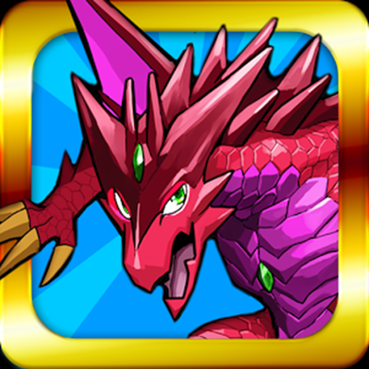

Elie Godbout

eliegodbout@gmail.com

McKenzie College

Course: SWTS1104

# Version History

|  |  |  |  |
| --- | --- | --- | --- |
| Version: | Editor: | Description: | Date: |
| Version 1.0 | Elie Godbout | Initial document for puzzles and dragons requirements | 05/06/2017 |
| Version 1.1 | Elie Godbout | Revision of the PAD database SRS document | 05/09/2017 |

Table of Contents

Version History 2

1 Introduction 4

1.1 Purpose 4

1.2 Scope 4

1.3 Product overview 4

1.3.1 Product perspective 4

1.3.2 Product functions 4

1.3.3 User characteristics 6

1.3.4 Limitations 6

2 References 6

3 Specific requirements 6

3.1 External interfaces 6

3.2 Functions 6

3.3 Usability requirements 6

3.4 Performance requirements 6

3.5 Logical database requirements 7

3.6 Design constraints 7

3.7 Software system attributes 7

3.8 Supporting information 7

4 Verification 7

4.1 External interfaces 7

4.2 Functions 7

4.3 Usability requirements 7

4.4 Performance requirements 7

4.5 Logical database requirements 7

4.6 Design constraints 7

4.7 Software system attributes 7

4.8 Supporting information 8

5 Appendices 8

5.1 Assumptions and dependencies 8

5.2 Acronyms and abbreviations 8

# 1 Introduction

## Purpose

The purpose of this system requirement specification document is to detail the functionality of the Database built for use in expanding a player’s experience with the puzzles and dragons mobile video game.

## Scope

The PAD Database aims to help players coordinate their monsters and teams so they may be more effective when playing puzzles and dragons.

## 1.3 Product overview

In this document, we will look at what the PAD database is and how it functions in order to enhance the player experience by improving plans and strategies.

### 1.3.1 Product perspective

Puzzles and dragons is a video game where one of your main objective is to collect and fight with monsters. With the use of the PAD database, we aim to simulate the team building aspect of puzzles and dragons with a player’s specific monsters so they may learn what combination of monsters best fit certain situations and see what other players are doing with their teams all so the player experience in puzzles and dragons will be made easier without removing from the fun.

### 1.3.2 Product functions

The PAD database is a reflection of the relationships found in the puzzles and dragons functionality. The diagram bellow is a representation of those relationships found in the PAD database.

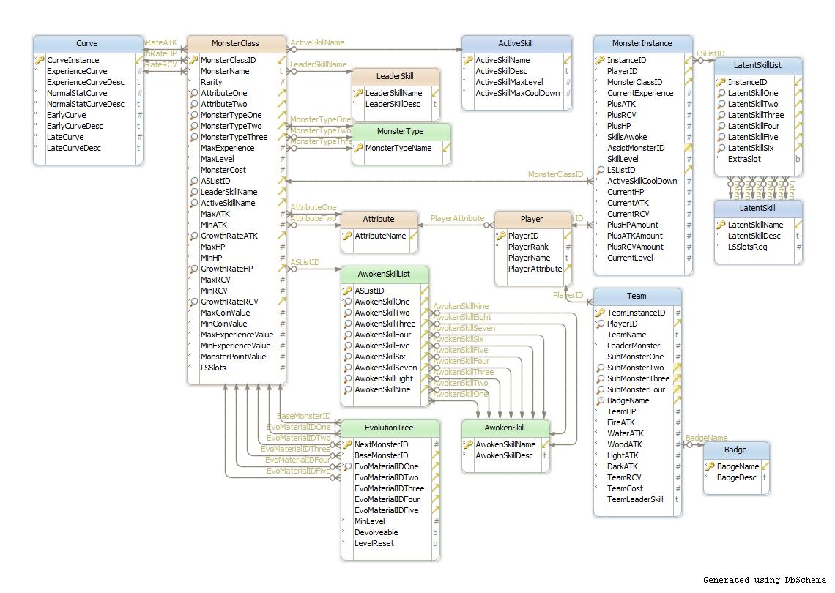

NOTE: The PAD database is currently still in development.

By using the many tables in the database, a player’s monster will easily be identified within the database and thanks to the monster instance table, all the unique properties of a given monster will also be recorded. When it comes to building a team, a player simply selects the desired monsters and all properties will be calculated as it would be in puzzles and dragons.

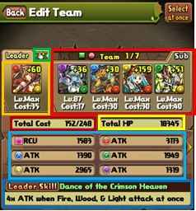Here we have an image of the in-game puzzles and dragons teams.

Current Badge equipped

Current leader monster’s leader skill

Total team’s HP

The sub monsters slots

Total RCV and ATk for each attribute

Total team cost

Leader monster slot

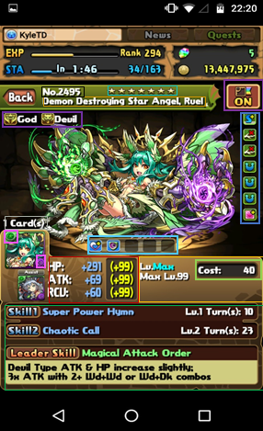Here we have an image of the monster properties in puzzles and dragons

Active skill and leader

2nd active skill (if assist is present)

Current level and Max level

Monster cost

Monster attributes and secondary attribute

Monster stats and monster stat bonuses

Number monsters of the same ID you own

Latent awoken skills

Awoken skills

Monster Type

Monster rarity

Favorited monster

Monster Name

Monster ID number

### 1.3.3 User characteristics

Puzzles and dragons is a world renowned mobile game meant to be played by anyone and everyone with access to a mobile smart phone.

* Apple IOS 6.0
* android 2.3 – 7.0,
* kindle Fire (2nd generation)
* Kindle HP
* Kindle Fire HDX.

PAD database must accommodate the same player base. However, it is unclear if the PAD database will reside strictly on laptop and desktop computers or if it will eventually transition to mobile devices as well.

### 1.3.4 Limitations

* The PAD database is currently limited to developers and/or testers only.
* Current network functionality limited to developers and testers only.

# References

* International standard ISO/IEC/IEEE 29148 first edition 2011-12-01
* <http://www.gunghoonline.com/games/puzzle-dragons/>
  + Puzzles and dragons’ official website
* <https://play.google.com/store/apps/details?id=jp.gungho.padEN&hl=en>
  + Puzzles and dragons google play store page
* Puzzles and dragons video game (On android device: Samsung galaxy S5)

# Specific requirements

## External interfaces

The PAD database currently does not have any external interfaces relating to end users.

## Functions

The PAD database uses player input for their unique monsters and then will be followed up with more inputs regarding the decision of which monster is used within the team simulator. The Database will take care of building the team and then presenting the user with the results.

## Usability requirements

Currently, the PAD database is limited to developers and testers only.

When product is launched, it is assumed that users will require an internet connection to then browse for the database’s end program. No knowledge of puzzles and dragons is necessary to use the program. Knowledge of puzzles and dragons will be an asset.

## Performance requirements

* network servers will be required in order to function as intended.
* Internet connection will be required.

## Logical database requirements

NOTE: the PAD database is currently still under development

* The PAD database must be able to handle multiple users at once at anytime of day
* The PAD database should remember the users registered monsters
* The PAD database should uniquely identify instances of each monster so no duplicates are present
* Users should not be able to access the database functionality.

## 3.6 Design constraints

* The PAD database is limited to the reflecting functionality of the puzzles and dragons game. (monsters available, team builder, etc.)
* It is currently unclear as too how many monster instances and players the database will be capable of supporting

## Software system attributes

The PAD database must be able to perform calculations in order to simulate team building.

## 3.8 Supporting information

The PAD database currently does not have any supporting information.

# 4 Verification

All previous elements of the PAD database are still under development and is subject to change.

## 4.1 External interfaces

Currently no external interfaces to verify

## 4.2 Functions

Verification of the PAD database functions will be conducted by the developers by using their own puzzles and dragons account and monsters.

## 4.3 Usability requirements

Currently no Usability to verify

## 4.4 Performance requirements

Network is currently only reserved to the development team.

## 4.5 Logical database requirements

PAD database is currently unfinished and cannot be verified

## 4.6 Design constraints

The development team will ensure the calculations will reflect the exact calculation found in puzzles and dragons.

## 4.7 Software system attributes

The development team will ensure the calculations will reflect the exact calculation found in puzzles and dragons.

## 4.8 Supporting information

The development team will create support information for users when the PAD database is complete.

# 5 Appendices

## 5.1 Assumptions and dependencies

* Users will have an existing account of puzzles and dragons
* Users will have access to the internet

## 5.2 Acronyms and abbreviations

**Puzzles and dragons:** *title of the mobile video game*

**PAD:** *acronym for Puzzles and dragons*

**Monsters:** *Characters in Puzzles and dragons*

**Monster box:** *area in puzzles and dragons where a player’s monsters are located*

**Team**: *Group of monsters used in puzzles and dragons’ combat*

**Leader:** *monster set in a leading position within the team*

**Sub-Monsters**: *Other monsters within the team*

**Attribute:** *defining property of a monster*

**Monster type**: *defining property of a monster*

**ATK:** *(Attack) status of a monster defining its combat potential*

**HP*:*** *(Health Points) status of a monster defining its strength*

**RCV*:*** *(Recovery) status of a monster defining its potential to recover lost HP*

**Active Skills:** *Special power used in gameplay by a monster*

**Leader Skills:** *Special passive power only available when a monster is placed in a team’s leader position*

**Awoken skills**: *special bonuses used to enhance a monster permanently*

**Latent Skills**: *removable special bonuses used to enhance a monster*